# COMPUTER SCIENCE & ENGINEERING

|  |  |
| --- | --- |
| **Student Name: Mahasvi** | **UID:** 22BCS10414 |
| **Branch:** BE-CSE | **Section/Group:** IoT_631(B) |
| **Semester:** 6th | **Date of Performance:** 17/02/25 |
| **Subject Name:** AP LAB-II | **Subject Code:** 22CSP-351 |

1.

FIND PEAK ELEMENT:

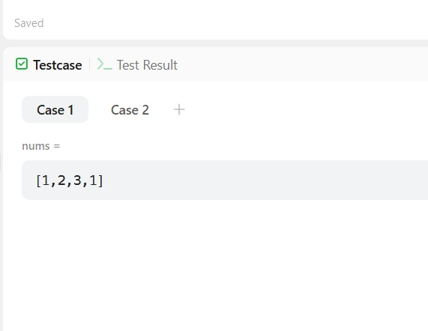

1. TOP K FREQUENCY ELEMENT:

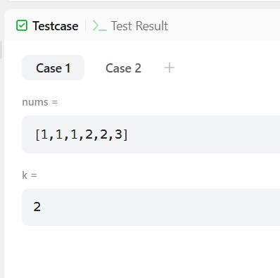

|  |
| --- |
|  |

1. **K largest element**

# COMPUTER SCIENCE & ENGINEERING

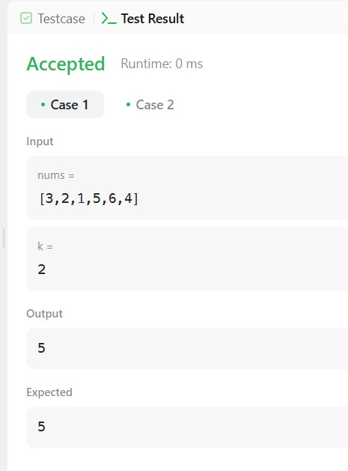

**4. Merge sorted array**

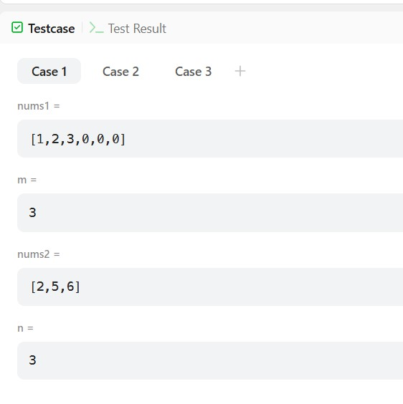

# COMPUTER SCIENCE & ENGINEERING

5. K smallest element

